Lab 2
Areesha Raheel
55039
Problem solving
Lab Tasks
1. An e-commerce warehouse has a set of products with known weights and values. A delivery truck has a weight limit of 50 kg. The warehouse manager needs to maximize the value of the products loaded onto the truck while staying within the weight limit.
Task:
1. Given the following products:
- Product A: Weight = 10 kg, Value = $60
- Product B: Weight = 20 kg, Value = $100
- Product C: Weight = 30 kg, Value = $120
Build a Profit Table using the 0/1 Knapsack Algorithm to determine the maximum possible value the truck can carry. Include an explanation of how the algorithm's dynamic programming approach is applied.

Task 1: Profit Table (Dynamic Programming)

🔹 Given Data:
Product | Weight | Value
A | 10 | 60
B | 20 | 100
C | 30 | 120
Knapsack Capacity = 50 kg

Formula Used:
V(i,w)=max⁡(V(i−1,w), V(i−1,w−wi)+pi)V(i,w)=\max\big(V(i-1,w),\;V(i-1,w-w_i)+p_i\big)V(i,w)=max(V(i−1,w),V(i−1,w−wi​)+pi​)

🔹 Profit Table
Items / Capacity | 0 | 10 | 20 | 30 | 40 | 50
0 Items | 0 | 0 | 0 | 0 | 0 | 0
A (10,60) | 0 | 60 | 60 | 60 | 60 | 60
B (20,100) | 0 | 60 | 100 | 160 | 160 | 160
C (30,120) | 0 | 60 | 100 | 160 | 180 | 220

🔹 Final Answer:
Maximum Value = 220
Selected Items:
- Product B (20, 100)
- Product C (30, 120)
Total Weight = 50
Total Value = 220

- Modify the 0/1 Knapsack Problem implementation to print the items selected in the knapsack that form the maximum profit. Display their weights and values.
1. Dynamic Programming (with Selected Items)
#include <iostream>
#include <vector>
using namespace std;

int main() {
vector<int> weights = {10, 20, 30};
vector<int> values = {60, 100, 120};
int capacity = 50;
int n = weights.size();

// DP Table
vector<vector<int>> dp(n + 1, vector<int>(capacity + 1, 0));

// Fill DP table
for (int i = 1; i <= n; i++) {
for (int w = 0; w <= capacity; w++) {
if (weights[i - 1] <= w) {
dp[i][w] = max(dp[i - 1][w],
dp[i - 1][w - weights[i - 1]] + values[i - 1]);
} else {
dp[i][w] = dp[i - 1][w];
}
}
}

cout << "Maximum Value: " << dp[n][capacity] << endl;

// Backtracking to find selected items
int w = capacity;
cout << "Selected Items:\n";

for (int i = n; i > 0; i--) {
if (dp[i][w] != dp[i - 1][w]) {
cout << "Weight = " << weights[i - 1]
<< ", Value = " << values[i - 1] << endl;
w -= weights[i - 1];
}
}

return 0;
}
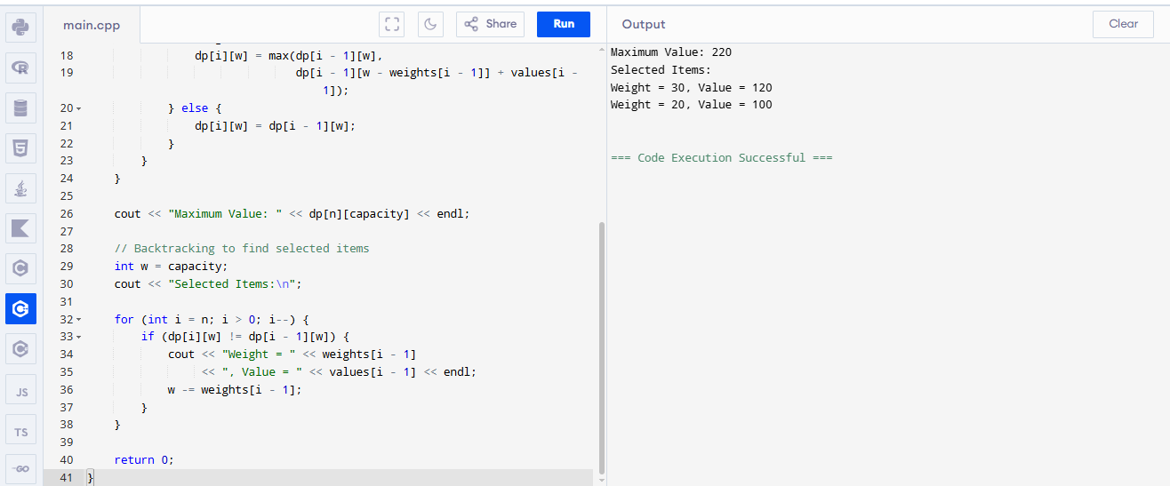
- Implement a recursive solution for the 0/1 Knapsack Problem (without using Dynamic Programming). Compare the execution time of the recursive solution and the dynamic programming solution for the same input.
#include <iostream>
using namespace std;

// Recursive function
int knapsackRecursive(int weights[], int values[], int n, int capacity) {
if (n == 0 || capacity == 0)
return 0;

if (weights[n - 1] > capacity)
return knapsackRecursive(weights, values, n - 1, capacity);

return max(
knapsackRecursive(weights, values, n - 1, capacity),
values[n - 1] + knapsackRecursive(weights, values, n - 1, capacity - weights[n - 1])
);
}

// MAIN FUNCTION (IMPORTANT 🔥)
int main() {
int weights[] = {10, 20, 30};
int values[] = {60, 100, 120};
int capacity = 50;
int n = 3;

int result = knapsackRecursive(weights, values, n, capacity);

cout << "Maximum Value (Recursive): " << result << endl;

return 0;
}

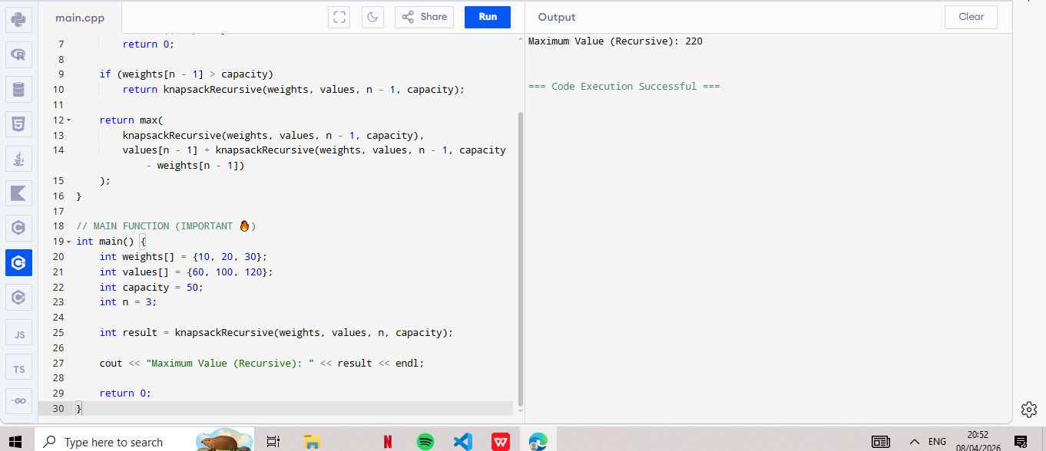

Comparison
Method | Time Complexity | Speed
Recursive | O(2^n) | Slow
Dynamic Programming | O(n × capacity) | Fast

